Peace Mala Accreditation – Bronze Award
Central Primary School Port Talbot
Spring 2019

“Creative Education that Empowers and Embraces All – Uniting the World in Peace”

Area one
Becoming a Peace Mala School is part of the whole School Development Plan approved by staff and the Governing Body. This is shared with the whole school community. A chosen year group will need to study and explore Peace Mala by using the kits and educational materials during a particular term every year. This encourages Peace Mala continuity in the school curriculum. The school will also share good practice with other schools who are members of the global community of Peace Mala.

Actions and Evidence for Area One
Peace Mala is in the School Development Plan approved by staff and the Governing Body. This has been shared with the whole school community and has involved assemblies. Peace Mala is also included in the school curriculum and policy for Education for Sustainable Development and Global Citizenship (ESDGC). The school has a prominent designated notice board and newsletters which details Peace Mala activities. Peace Mala is also promoted on the school website and on Twitter/social media.
In the Autumn of 2017, Pam Evans, founder of Peace Mala visited the school and gave a whole school assembly. This was well received and inspired pupils and staff. The school also became sponsor/guardians of one of the Symbolic Doves of Peace. In the Autumn term of each new school year, Year 3 make and wear the Peace Mala from the educational kit.
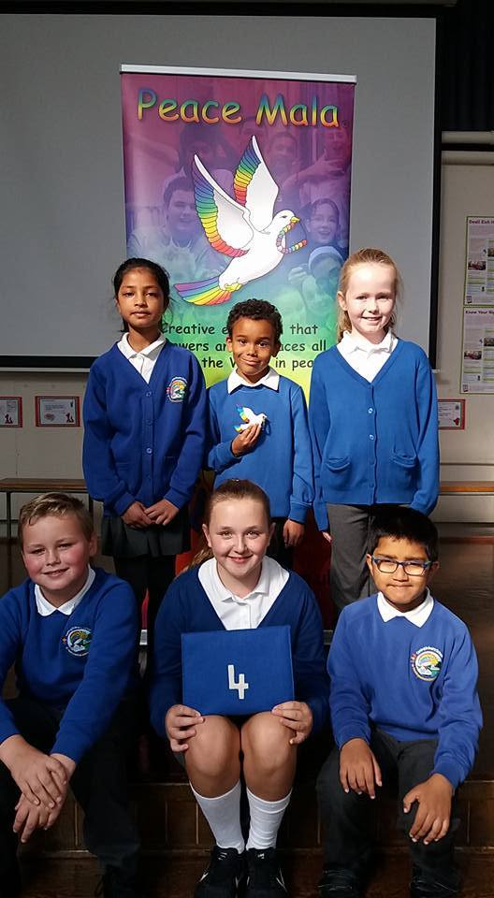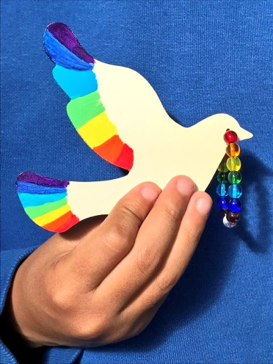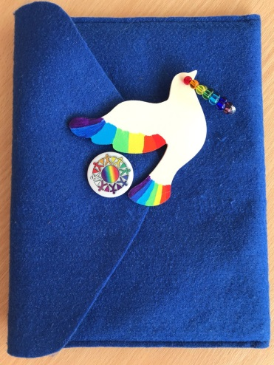
Peace Mala Symbolic Dove of Peace number 4 was named ‘Lalasa’ (Sanskrit for ‘love’) by Ella Flint-Mortimer Year 5.

Peace Mala Assembly held by Pam Evans 28th September 2017
The above photos and messages were shared on Twitter.
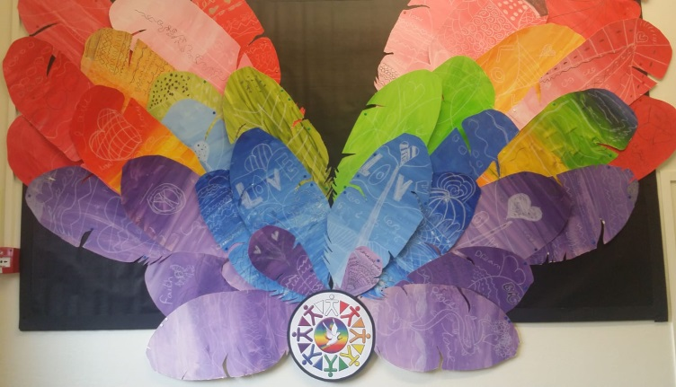
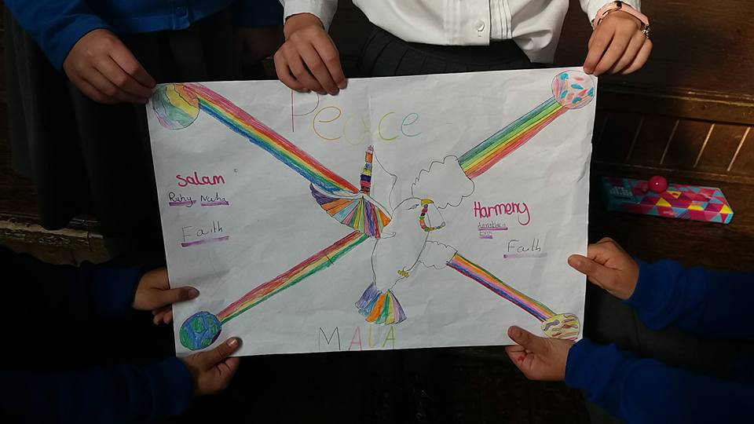
Pupils were inspired after the assembly and independently created a poster during their playtime to represent the message of Peace Mala.

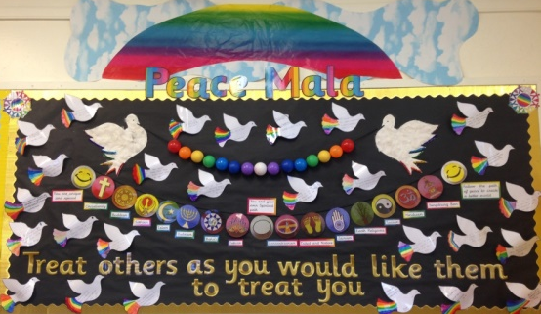
Year 6 have made feathers in rainbow colours with peaceful words on them for a display
Year 3 children have written Haiku poems based on Peace Mala and produced a classroom display of their work.

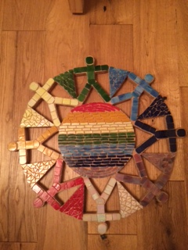

The school produces newsletters to share with parents, staff and governors every week and always contain the Peace Mala Logo and news
We have had the Peace Mala dove and logo cut out of wood and then covered with pieces of coloured glass to make a mosaic for display around the school.

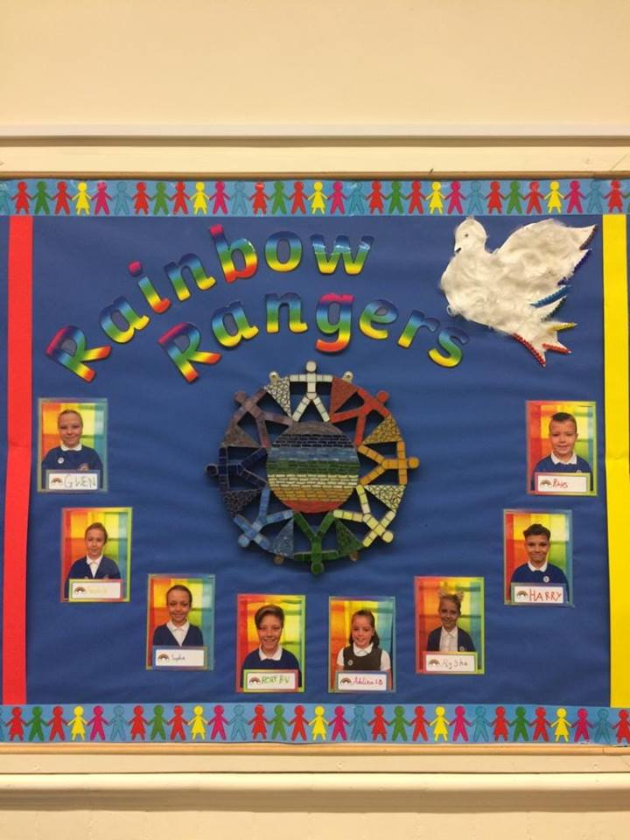
The Peace Mala logo has been used to display the children who are Rainbow Rangers for our school.
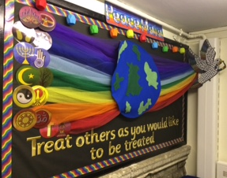
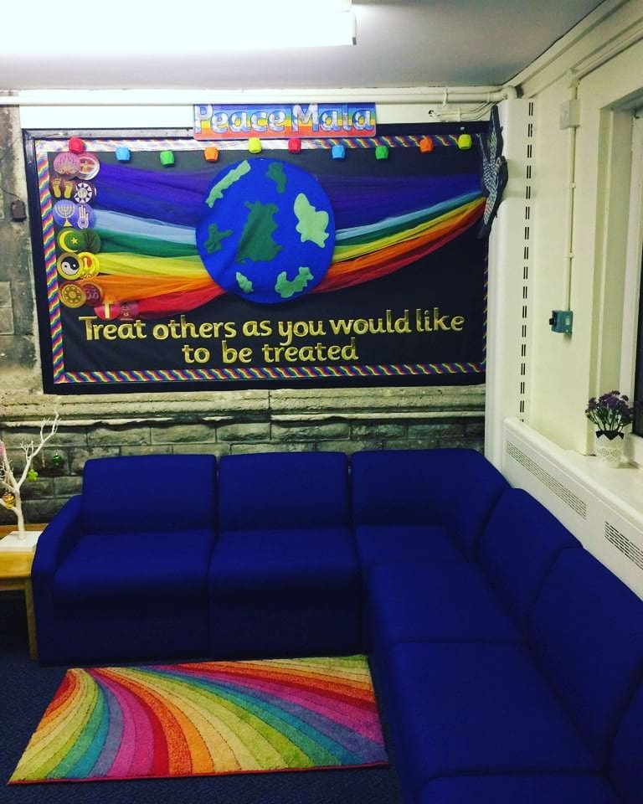

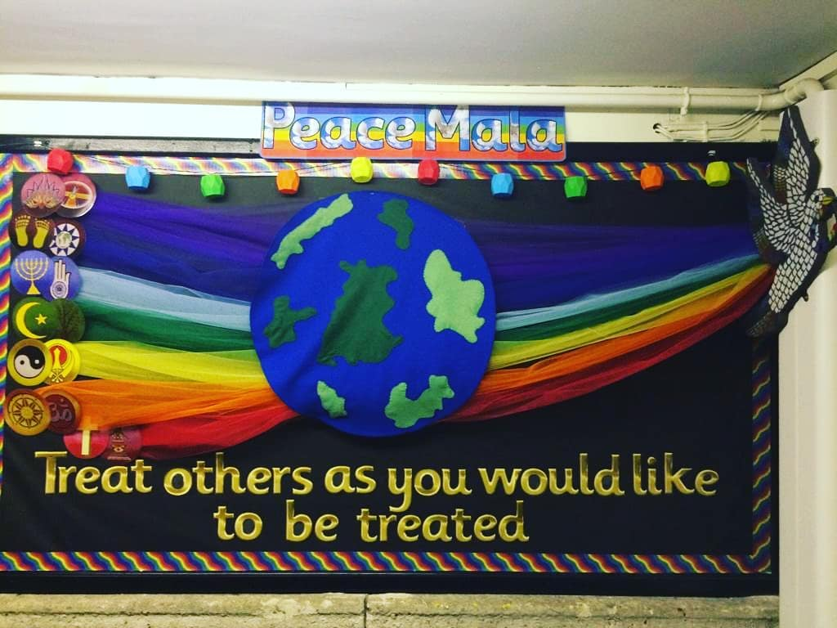
We have the Peace Mala Golden Rule on display in our school foyer. The dove carries the message of peace throughout the world and through all religions.

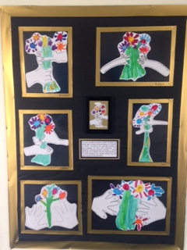
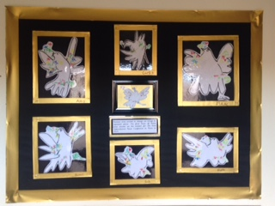

Art work also on display in the foyer based on Picasso and his bouquet of peace
Display of children’s art work in the foyer at Central based on Picasso and his dove of peace

Area 2
By engaging with Peace Mala the school is committed to education for global citizenship through the promotion of understanding, respect, friendship, tolerance and peace between all communities, cultures and enlightened, compassionate faiths. Peace Mala promotes and encourages community cohesion.
Actions and evidence for Area Two
Lessons and activities on Peace Mala are part of the school curriculum. School assemblies take place on a daily basis and focus on the Golden Rule. As a whole school we have taken part in Education for Global Citizenship week with different year groups focusing on different global issues. Year two focused on the theme of water and how fortunate we are to have a clean supply unlike children from developing countries. Year 5 focused on Fairtrade and year 6 learnt about the effects of global warming. Year 3 focused on the journey of a banana and how we are dependent on other countries for our fruit. They learnt how much of an impact Fair Trade bananas have on the farmers that work on large plantations in different countries.
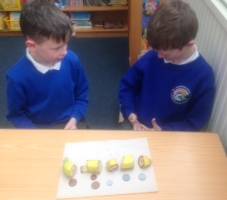
Pupils splitting a banana up into 5 pieces and discussing the fairness of the amounts of money that people involved in the journey of a banana get

Year 3 have focused on making Peace Mala bracelets so that the message filters through the school as they grow and move through each key stage
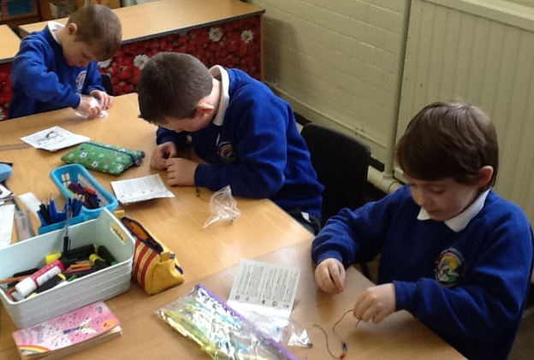
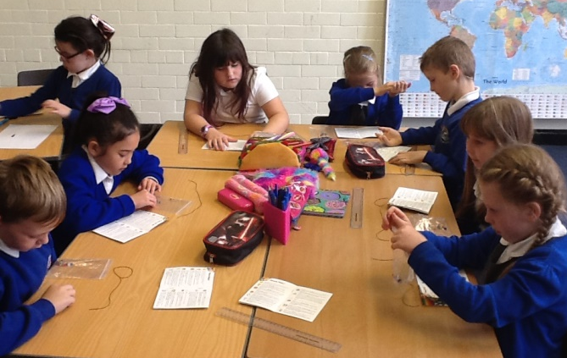

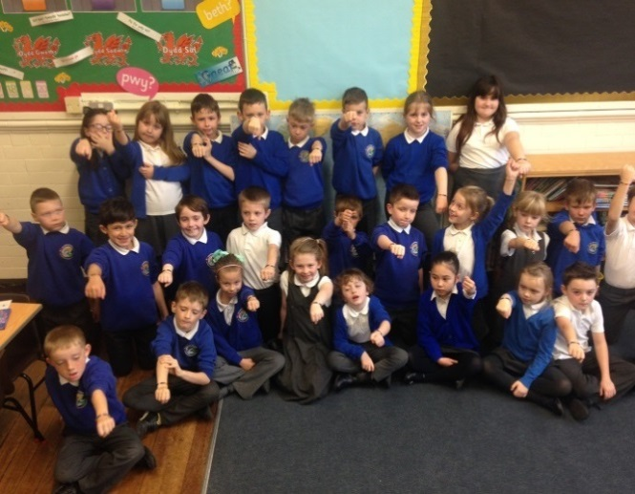
All of Year 3 successfully made a Peace Mala each whilst learning the significance of each bead and the peace message of each faith.

Area 3
By using Peace Mala in the classroom, the school supports human rights and helps prevent bullying and all forms of prejudice.

Actions and evidence of Area 3
As a school, we have an anti – bullying policy approved by governors. Assemblies are delivered throughout the year by teachers, pupils and anti – bullying organisations. We also have an annual anti – bullying week where the pupils wear yellow to school as it is the colour of friendship. We have a ‘Buddy Bench’ in our school yard that children can go and sit on if they are in need of a friend or want to share their troubles.
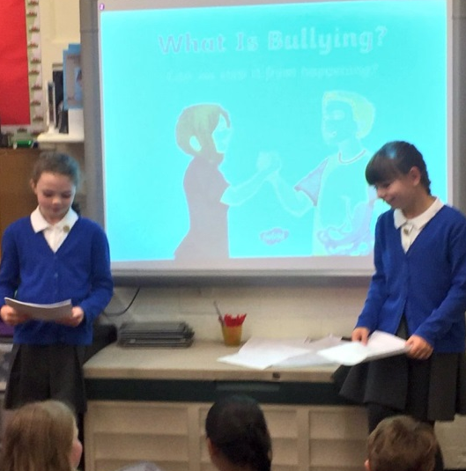

A representative from the NSPCC delivered an assembly to all KS2 children in the hall to raise the profile and develop understanding.
Mrs Hopkins delivers an assembly to the whole school during anti bullying week.
Pupils in year 5 independently made a PowerPoint on the definition of bullying and how to deal with it and presented it to their peers.

This newsletter was sent out to parents in November to raise awareness of anti-bullying week.

Area 4
Peace Mala encourages the school to raise awareness of issues of global interdependence and encourages active compassion by learners that will lead to positive changes locally and globally.
Actions and Evidence of Area 4
As a whole school we organise and take part in numerous activities to raise awareness of issues of global interdependence and encouraging active compassion both locally and globally. We take part in all international fundraising days such as Red Nose Day and Children In Need.
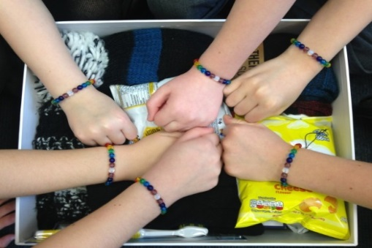
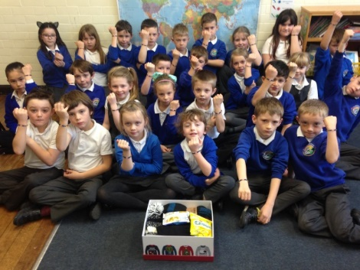
Children collected items and packed them into shoe boxes to be distributed to homeless people at Christmas time.

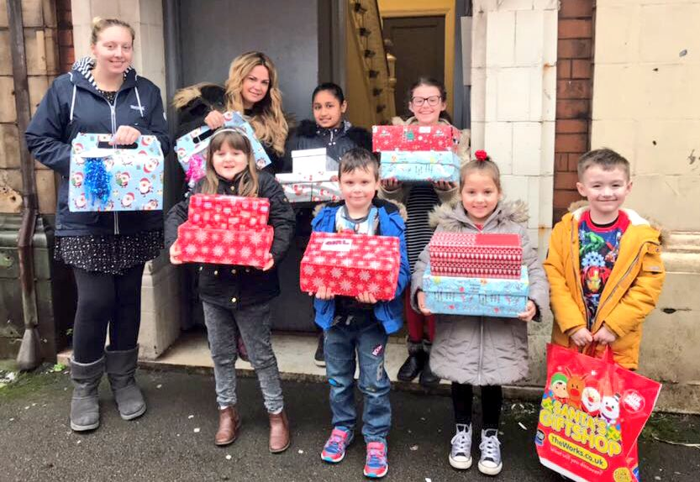
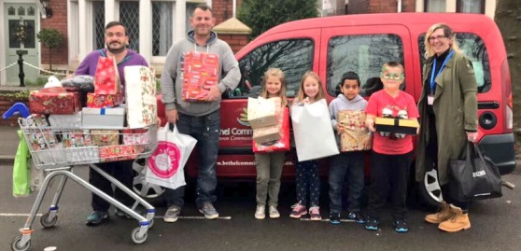
Supporting the vulnerable and homeless members of our community (posted on Twitter)
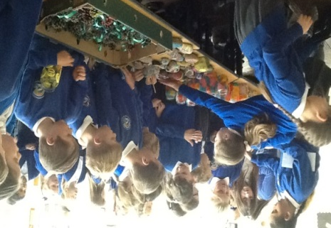
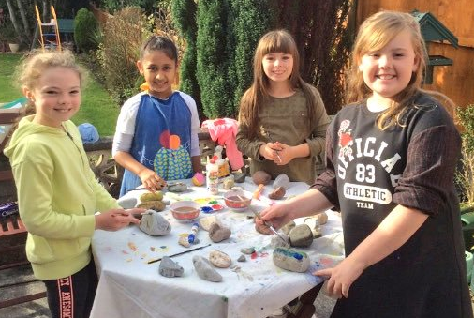
Year 5 children making and selling crafts to raise money for a school in Toanga

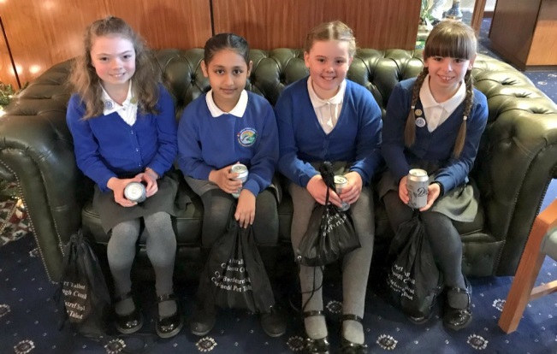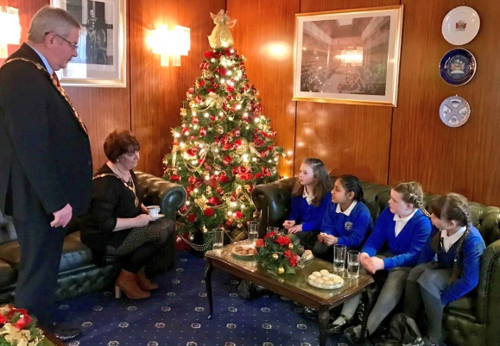
The year 5 pupils raised over £200 in funds for the Toango School in Zambia and were congratulated by the Mayor of Neath Port Talbot for their compassionate efforts. This was shared on Twitter.

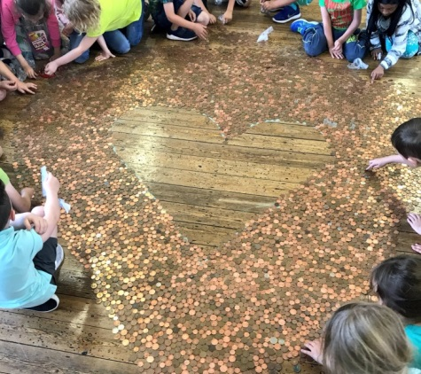
The whole school brought in their spare coppers to make a trail which was then donated to the Grenville Towers fundraising appeal.

Area 5
Peace Mala encourages the celebration of cultural, racial and religious diversity through art, music, drama and dance.
Actions and Evidence for Area 5
At Central, we constantly celebrate cultural diversity as part of our curriculum. We deliver assemblies and lessons to celebrate other religious festivals. We have a link with our local mosque and the Iman comes to take part in our assemblies. We celebrate International Diversity Day annually with various activities. We have developed links with a school in Taonga in Zambia and have fundraised as a school to help them.
We celebrate St David’s day annually by holding an Eisteddfod in the local church where children sing and perform through the medium of Welsh. A harpist visits school to share Welsh culture through music. We learn welsh folk dances and perform them for parents.
We also hold Eid Festival celebrations every year. Children take part in tasting different foods, dressing in traditional clothing and taking part in traditional dancing.
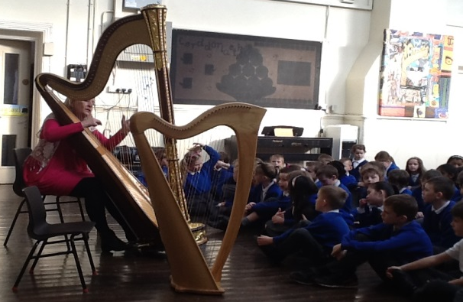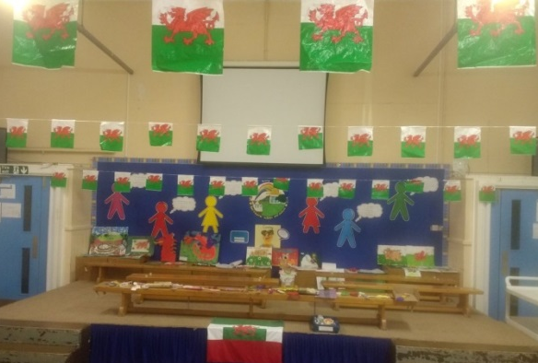
Stage decorated for Infant school sharing of all things Welsh.
Visit from harpist to share welsh culture through music.

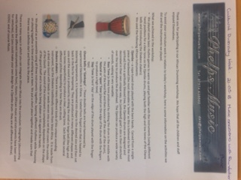

An African drummer group came to school and all children had a go at playing the African drums.

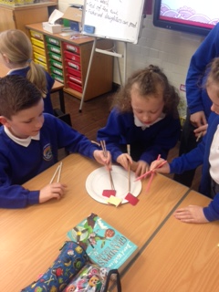
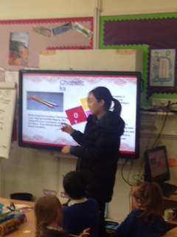
We celebrated Chinese New Year by using chopsticks, making lanterns, learning the signs of the zodiac and listening to a Chinese lady telling us how Chinese people celebrate.

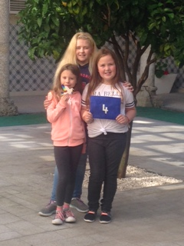
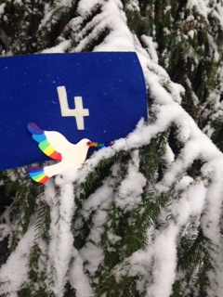
Lalasa has travelled to Finland on an International Schooling Links Project where Central developed links with different schools.

Lalasa has also travelled to Spain with 3 children on a robotics programme where we made links with some Spanish schools.

Area 6
With Peace Mala the school actively promotes environmental sustainability, healthy eating, and respect for all animals and wildlife.
Actions and Evidence for Area 6
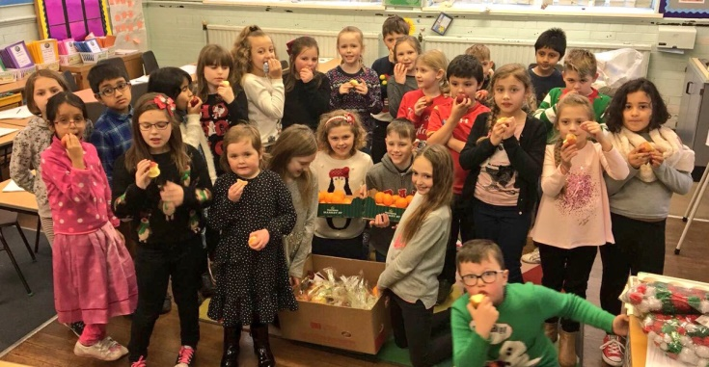
In Central, we constantly promote the need for healthy eating. We run a tuck shop where children can buy fruit and a bottle of water at break times. We have a Healthy Schools working party that meet on a regular basis and we also hold a healthy week every year. We encourage children not to bring chocolate or fizzy drinks into school.

Year 4 enjoying their piece of fruit that was donated to our school by Morrisons to take on a cinema trip.

We also have a School Eco council that meet on a regular basis. As part of their daily role they monitor lights to make sure they are not left on when the classrooms are not in use. We also have a paper recycling bin in each classroom and recycling bins for plastic and food.
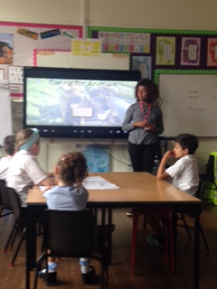
We have two guinea pigs that join us in school each day and children benefit by taking responsibility for looking after them and caring for them. In the spring and summer terms children weed and tidy the school garden area and plant different seeds and flowers. They also take part in activities such as making bird feeders and making ‘bug hotels’. In the autumn term we were lucky enough to receive a two day visit from Claire who works for the Dogs Trust. She took a whole school assembly which promoted the importance of being a responsible dog owner and respecting and looking after dogs. This was followed up by lessons in each classroom encouraging children to be responsible dog owners and to care for animals appropriately. Year 3 also received a visit from a student who is studying to become a veterinary nurse who spoke to the children about caring for animals.

Student vetinary nurse presenting a PowerPoint to year 3 about caring for animals

Claire from The Dogs Trust taking a whole school assembly and classroom based activities based on caring for animals.

Area 7
With Peace Mala the school encourages Peace Education by forming a School Peace Council and engaging in peace activities.
Actions and Evidence for Area 7
Pupils in all year groups were asked to apply to be part of our school peace council. They then had to present to the rest of the class why they thought they would be the right candidate to be in the peace council and the class had to vote who they thought would be the best. We had our first meeting and decided we wanted to call ourselves the ‘Rainbow Rangers’. The rainbow Rangers have also had the opportunity to make themselves a Peace Mala each and have a Peace Mala logo badge to wear to identify themselves to the rest of the school.
We consider ourselves to be a peaceful school and we do lessons on peace and mindfulness. We also do meditation and stilling exercises using a website called Cosmic Kids. We were very privileged to have attended the Peace Mala Liturgy for World Peace Day in September 2018 in Neath, which we all very much enjoyed. We also attended Catwg School to watch them receiving their accreditation in the autumn term.
We have had a five foot wooden tree made which we painted gold to use as our peace tree. It is displayed in the hall for all to see and children hang messages/poems/prayers of peace on it.
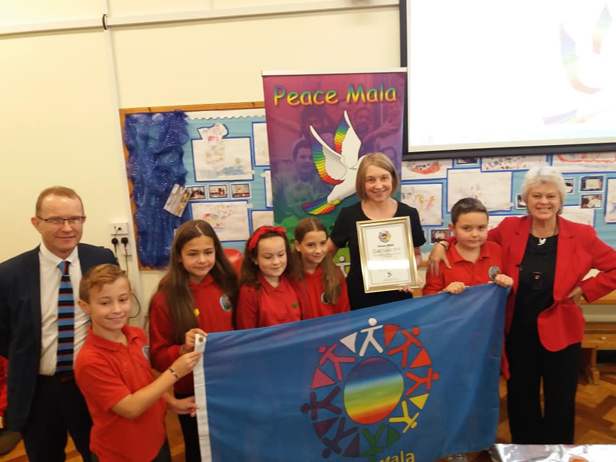

Our Rainbow Rangers for Peace Mala attending Catwg Primary School’s Gold Award Accreditation ceremony, along with the Director of Education for Neath Port Talbot.
Central Rainbow Rangers celebrating with Catwg Primary the accreditation that they achieved.

Peace Mala Liturgy for World Peace at St David’s Church Neath September 201. Central pupils attended and took part, along with pupils from 10 other local Peace Mala schools.

Central ppil
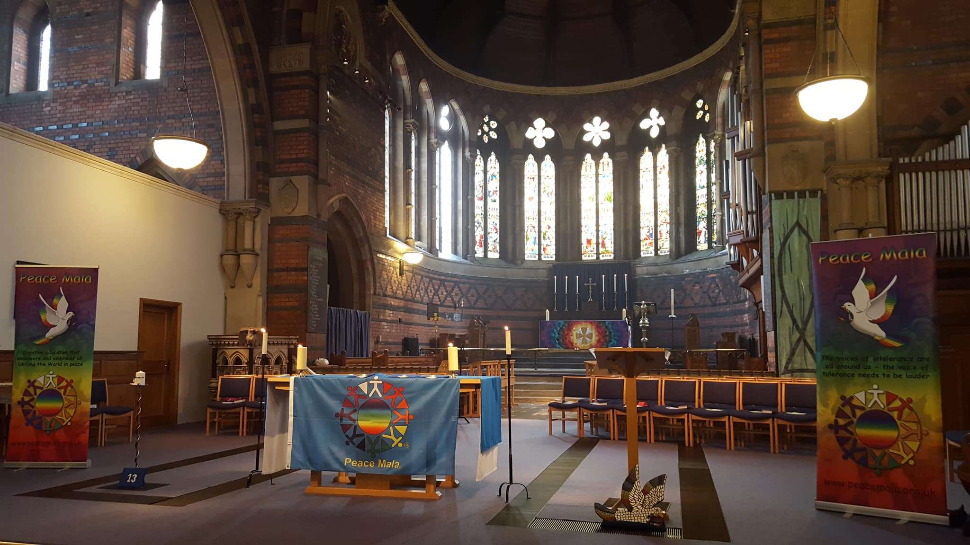
The church prepared for the Peace Mala world peace service
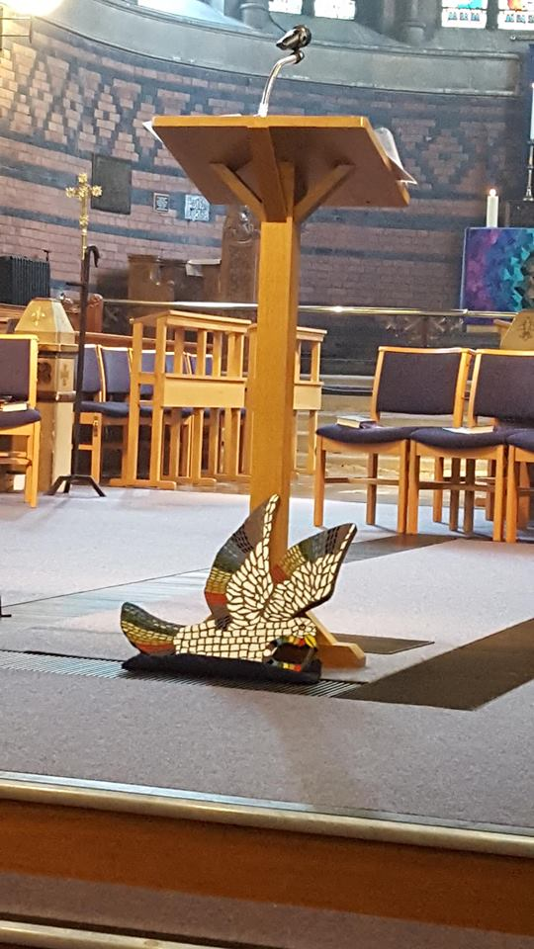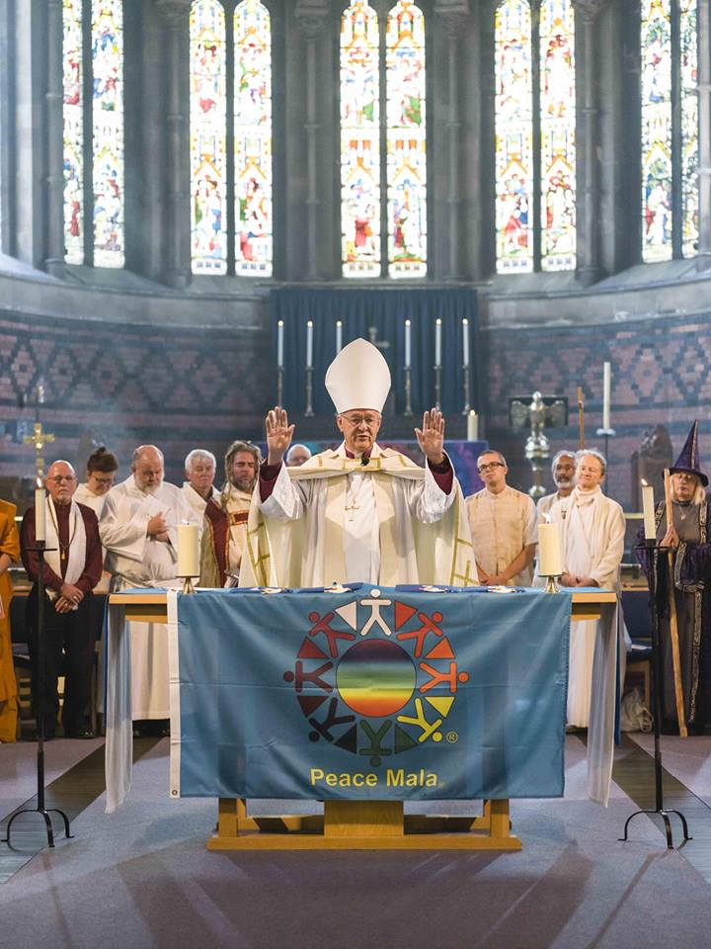
Our ceramic dove of peace beneath the lectern. Archbishop John of Wales, giving the final blessing

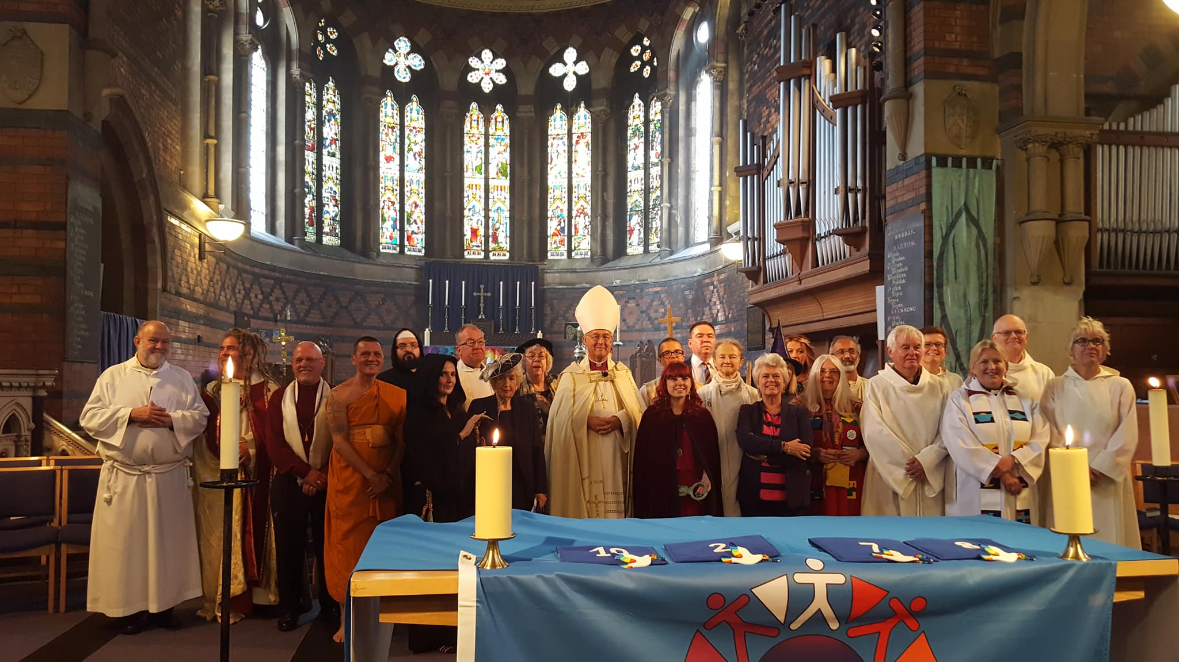
Archbishop John and Pam Evans, with representatives of many faith traditions who attended and took part in the service for world peace

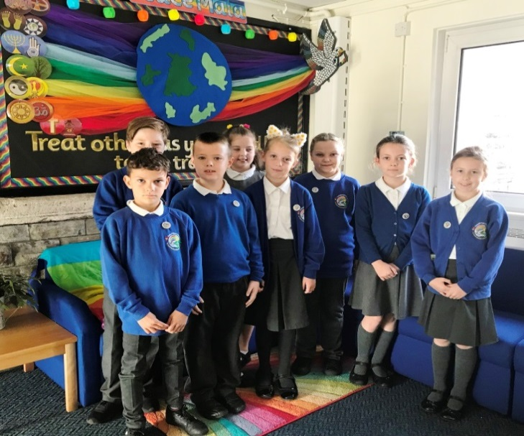
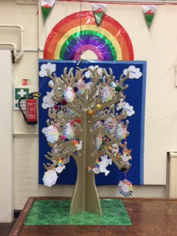
Our Rainbow Rangers and our tree of peace
Our gold Peace tree with messages of peace that the children have written
Rainbow Rangers in our Peace Mala foyer at the entrance of our school

