Baguley Hall Primary School, Manchester
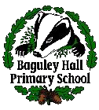
Peace Mala Accreditation Self Assessment Evidence
November 2015
Area 1
Becoming a Peace Mala School is part of the whole School Development Plan approved by staff and the Governing Body. This is shared with the whole school community. A chosen year group will need to study and explore Peace Mala by using the kits and educational materials during a particular term every year. This encourages Peace Mala continuity in the school curriculum. The school will also share good practice with other schools who are members of the global community of Peace Mala.

At Baguley Hall School we celebrate the diversity of faiths, cultures and lifestyles. This developed from a cluster meeting involving Newall Green, Benchill and Baguley Hall Primary School in June 2014 where Shelley Lynton (Peace Mala Co-ordinator) introduced ‘Peace Mala’ to an extremely inspired Kate Bulman (our Head Teacher). Kate then spoke to myself (Amy Grundy) and I immediately became an advocate of this inspirational organisation. From that day onwards we began a passionate journey to gaining Peace Mala accreditation. The journey has been exciting and incredibly rewarding; it has been a real privilege for all members of staff to observe the impact the teachings of Peace Mala have had upon our children. Every member of staff has played a part in our journey and I can confirm, on behalf of everybody at Baguley Hall, we are dedicated to ensuring that this vital message of peace continues for many years to come.

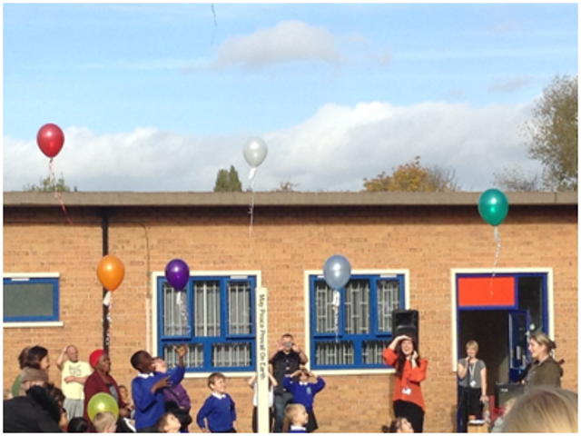
Launch of Peace Mala at Baguley Hall Primary School
Any Peace Mala work that we do is regularly fed back to the School Governors, through Kate Bulman. They are informed of all the opportunities it has led to and all of the benefits it provides not just to the children, but also the staff and the wider community. Half termly newsletters are sent to parents from the school notifying them of all the work the children and the school are involved in relating to the Peace Mala. In addition we have Peace days throughout the year to celebrate the different faiths and foster the, ever so important, message of peace and kindness. We ensure that celebrations of this nature end with after school events that involve the families and friends of the children and staff at the school- so that the message spreads out to the wider community too.
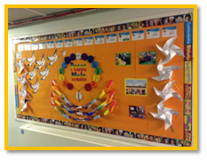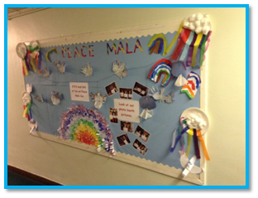
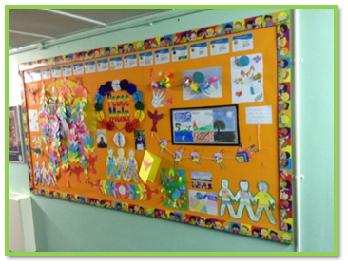
Peace Mala corridor displays
Along the school corridors there are a variety of vibrant displays that are designed to encourage the children to have tolerance, understanding and to embrace differences between them. These messages are encouraged by the wearing of the Peace Mala bracelet which are supplied not only for the Year 3 cohort but also as part the staff dress requirements. Since the introduction of Peace Mala last year, Mrs Bulman kindly supplied all of the staff with their own bracelet which had to be worn at school!
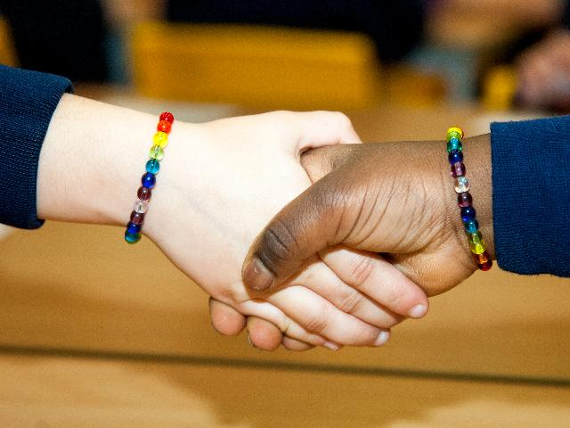
Earlier in the year children in Year 3 and 4 completed an Art project with The British Museum. The artwork was based around the messages of Peace Mala, such as kindness, respect, tolerance, love and peace. The children worked passionately to create the beautiful pieces of art, which are now displayed on the outside of the school building, for all to see. The project was a real success and lead to us gaining The Discover Arts Award. This has proved to be a fantastic talking point for visitors to our school and clear way of promoting our Peace Mala ethos.
There are also other key pieces of artwork displayed around the school, for example, above the stage in our main hall there are two large, wooden, Peace Mala doves. These were designed, painted and decorated by the children; each child took a real pride in ensuring that their coloured glass bead was placed in the correct position on the wings of the dove.
Our school web page has an area dedicated to the Peace Mala and faith projects that we have been involved in. We encourage all parents, children and people in the wider community to access this freely.
As part of our on-going School Development plan Peace Mala is integrated in to our RE education throughout the school. The children learn about Peace Mala and in Year 3 they get the chance to make the Peace Mala bracelets. This year, we are hoping to work alongside Jo Malaika, who works for Urban Peace, an organisation that promotes peace in her local area. She has agreed to come in and work with children in Year 3 as well as leading a debate session with the children in Years 5 and 6.
Promoting peace is the ethos of Baguley Hall. Bringing together all religions, races and cultures, celebrating differences and similarities and embracing every type of person is the message promoted by children and all the staff at the school. We want to teach the children to be kind, loving and peaceful and to spread the message as far as we can. We have been incredibly fortunate as we have been able to spread our message across the globe to Zambia through our link project with Primary Schools in this country. Teachers from our school have taught Peace Mala lessons to Zambian children and explained the importance of Peace Mala in staff meetings whilst over there. The Zambian teachers were also able to witness our Peace Mala teachings when they came over to visit our school.
As a school, we feel that it is imperative that Peace Mala is built into everyday life. To ensure that our children are regularly reminded of its importance, there is a rainbow flag displayed in each phase which is signed by every child and teacher. Upon signing the flag the children and teachers pledged a vow to follow the teachings of Peace Mala every day. These flags act as a clear, visual reminder to everyone at Baguley Hall to lead peaceful lives.
Area 2
By engaging with Peace Mala the school is committed to education for global citizenship through the promotion of understanding, respect, friendship, tolerance and peace between all communities, cultures and enlightened, compassionate faiths. Peace Mala promotes and encourages community cohesion.
Through our PSHCE/SEALS lessons the children explore prejudice. The children learn about differences through looking at examples and discussing terms such as stereotyping, racism, prejudice, ethnicity and ethnic pride. All of these messages are reinforced by the Golden Rule of Peace Mala. The lesson that we teach the children is that it is very important to respect themselves, others and personal belongings which is emphasised through each classes Class Charter. An important lesson for the children is to understand that as children they have rights, but they also have responsibilities. In PSHCE, the children are taught all about the special rights that they have as children and they are encouraged to think of the responsibilities that adults have to them.
We introduced Peace Mala on the week of October 8th 2014 with a full day of activities and events dedicated to Peace Mala. We had a variety of visitors to the school; including Christian, Buddhist and Islamic faith leaders who each gave an engaging presentation to the whole school about what peace means to their faith. Throughout the day children, staff and parents were involved in workshops and activities around the school; it was fantastic to see families, of all faiths, working together to celebrate peace. Parents were delighted to be involved in the event and many were heard asking Class Teachers when the next event would be.
The day ended outside on the field with the planting of the Peace Pole. It was an honour to have Glenda Thornton (from May Peace Prevail on Earth) with us at the ceremony. Before the peace pole was planted, one child from each class came forward and placed their classes decorated peace doves in the hole. The pole was then secured on top of the messages before it was cemented in place.
Throughout the event our music co-ordinator led us all in singing a selection of beautiful songs, all of which were based around the theme of peace. The final song of the event was ‘A little peace’ by Nicole. The children had learnt the sign language to this song so as they were singing around the peace pole they were also spreading the message of peace visually. Towards the end of the song a selection of parents came forward to gather around the peace pole with their children to release helium balloons, in the colours of Peace Mala, into the sky. The balloons had messages of peace attached to the bottom of each of them, which had been written by children across the school.
At Christmas time, each child was given a Christingle to decorate. Beforehand, the children were shown a PowerPoint which described the meaning behind the Christingle and how this links with Peace Mala. The children walked to the church for a special Christmas ceremony. At one point during the service the Peace Pals took their place at the front of the stage. The children snapped their glow sticks simultaneously to light up the church- the effect was magical!
Upon embarking on our journey to becoming a Peace Mala school we have focussed on the importance of sharing ideas and building relationships between schools locally and globally. I meet regularly with the Peace Mala co-odinators from schools in Wythenshawe such as Newall Green and Benchill. We always ensure that we attend events that are held by the other schools. I have been fortunate enough to attend Newall Green and Benchill for their Peace Mala events. This year, during our Peace Mala day, we will present the Peace Pals from the other two schools with a gift of peace. They have agreed to do the same for our school too. We are very much looking forward to the opportunity to take our Peace Pals back to Benchill to teach their school the sign language to our Peace Mala song.
The RE coordinator and I attended a PE course earlier in the year, where we met a primary school Teacher from St. David’s Primary school, a Jewish school in North Manchester. We discussed Peace Mala with her at length and she was very keen to participate in any way that she could. A few weeks later she brought 15 of her year 6 children to our school where they held a whole school assembly and informed us about Rosh Hashanah. They had even learnt a rap to teach our children about their traditions- the children were mesmerised!
Area 3
By using Peace Mala in the classroom, the school supports human rights and helps prevent bullying and all forms of prejudice.
Baguley Hall is a community of around 550 children and adults. We ask the children to be mindful of the prejudice that surrounds certain faiths and culture in the world and we need to work to stop this. As the Peace Mala warns ‘the voices of intolerance are all around us. The voice of tolerance needs to be louder.’
Every year we have a Disability awareness week which allows the children to see some of the disadvantages of disability as well as the power of self-belief and determination to succeed against all odds. We were fortunate enough to have been joined by different people, all of whom had disabilities of some kind. One gentleman described the drawbacks of being wheelchair bound during a whole school assembly. He then led workshops to children in every year group which included giving the children the opportunity to sit in his wheelchair. I felt immensely proud of the attitude of our children who all greeted our guests with warmth and acceptance. A few weeks after our visitors had been in school, Mr Rogers asked his reception class if they remembered our visitors, one little boy replied “do you mean the man in the red jumper?” It was a beautiful moment as it highlighted the level of acceptance that our children have, they didn’t see him as a man in a wheelchair, just an ordinary man in a red jumper.

One of our Teachers is very closely involved with a charity that supports Guide dogs. We were delighted when he agreed to bring one of the dogs in along with her trainer. They held assemblies and workshops for each year group and the children were fascinated to hear about the importance of guide dogs and the huge impact that they can have on a blind person’s life. The following day, our children enthusiastically wrote a recount of the previous day’s activities which highlighted the amount they had learnt. In the future we would like to sponsor a similar charity e.g. ‘Four Paws’ or ‘Adopt a Donkey’ as we feel that is it so important to encourage our children to show compassion towards animals.

As with most schools we have an anti- bullying policy and anti-bullying is taught in each year group through the use of the SEAL scheme of work. This is supported by our Peace Pals who offer friendship and support in the playground and are available for any children to engage with at playtime and lunchtime.
During one of our regular Peace pal meetings, one child suggested that each classroom creates a box to celebrate kind acts. We discussed this idea further and decided that it would be a fantastic way of celebrating and encouraging kindness and peace. Now, each class have their own ‘Random Acts of Kindness’ box which are used to highlight and celebrate the kindness that we encourage our children to show to each other. Every Friday, the messages are shared with the class and one name is chosen out of the box at random to receive a prize and the honour of being the Peace Mala Person of the Week!
During our latest Peace Mala day, the children in Year 1 were involved in creating a ‘friendship salad’. The ideology is that children see that it takes all kinds of fruit (people) to make a perfect fruit salad (classroom/world). They then discussed what would happen if a rotten banana was introduced to the fruit salad. This was a great way of discussing the topic of bullying with younger children and they all grasped the concept very well.
At Baguley Hall we are a Rights Respecting School and believe in the importance of children understanding their rights from a very early age. Throughout the year, we have participated in many whole-school events to promote an understanding of children’ rights. These have included whole-school assemblies, peer learning workshops held by children in UKS2 and a variety of activities based around wants and needs.

Area 4
Peace Mala encourages the school to raise awareness of issues of global interdependence and encourages active compassion by learners that will lead to positive changes locally and globally.
As a school we regularly give to charities. We raise money through a variety of means including own clothes days, pyjama days, ‘change for change’ which raises money for countries who have suffered global disasters and Macmillan cake sales. We always ensure that children are aware of the events and feel passionately that such activities give our children a deeper understanding of how we can be compassionate and work towards making both local and global positive changes.
The children have learnt all about people and organisations that have made a difference to the world. This involved learning about numerous charities, their founders and numerous people who have helped to make the world a better place through raising money, charities, technology, science etc. We have many links with the different places of worship and faith leaders in the community and beyond.
In July 2015, myself and Mr Rogers went to Zambia to teach for 2 weeks. We held a series of Peace Mala workshops which included Peace Mala t-shirt designing, creating a large scale rainbow made out of tissue paper, teaching the children the words and sign language to ‘A Little Peace’- our school’s Peace Mala song and creating lessons around books with Peace Mala values e.g. Elmer The Elephant. All workshops were extremely popular with the Zambian children and they were fully engaged throughout. We showed the children our Peace Mala Symbolic Dove of Peace No.2 and explained the important messages behind it. The children then created their own peace doves which we helped them to display to brighten up the bare walls of their classrooms. It was a privilege and a joy to be able to spread the values of Peace Mala to such responsive children. We gave the Zambian children a T-shirt which was created by our children. The T-shirt was decorated with Peace Mala values and colours. The children in Zambia then created their own T-shirt which we brought back to England as symbol of our friendship and as a vow to keep the Peace Mala promise.
During our time in Zambia we were very fortunate to cross paths with Rachael Webb, the Head Teacher at Hafod Primary school in Swansea. We met in Livingstone and were able to discuss Peace Mala at length and our plans to create a link between both primary schools. We also brought our peace doves and were able to have a photograph with ourselves and doves 2 and 3 which was great!
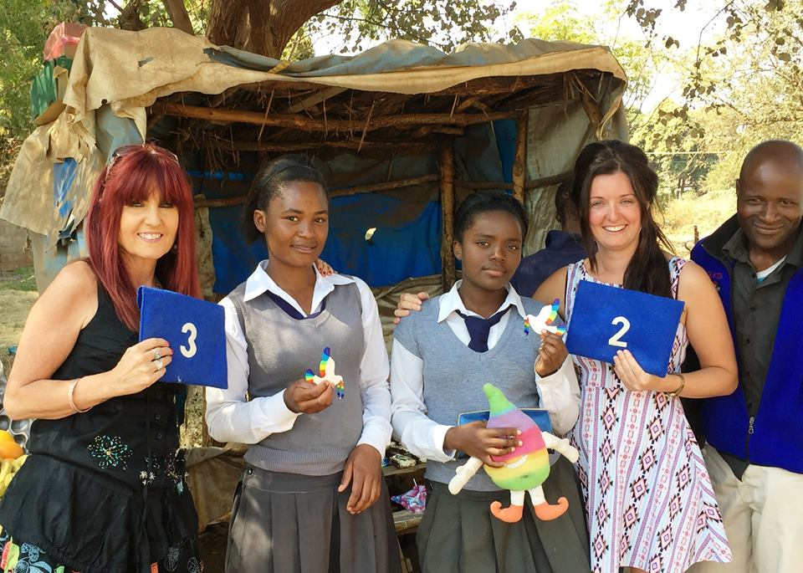
Meeting up with Rachael Webb in Livingstone Zambia
Most of the children at Baguley Hall aren’t fortunate enough to travel to different countries. To address this we have special days which look at the various countries and continents around the world. During these days we have enjoyed learning about their cultures, dress, food, languages etc. The children have tasted food from around the world and have explored where countries are in relation to England. The children then take part in special assemblies to share what they have learnt about their country with the different year groups to make sure we have vast coverage.
After the devastation that occurred in June 2015 on the beaches of Tunisia, our thoughts were instantly with the people of the country and what we could do, as a school, to show our sympathy to those who lost their lives and gratitude to those who saved lives. The children of Year 5 wrote a beautiful letter to the hotel workers who acted as a human shield to protect the innocent tourists from such terror. In the letter the children referred to the important messages that Peace Mala teaches us in these situations and expressed their gratitude and respect towards the workers. We were delighted to receive a reply from the hotel workers who were incredibly touched by our letter.
During one of our Peace Mala days, the year 5 and 6 children were given the task of researching and creating a presentation about people who have dedicated their lives to encouraging peace. The children gained such a lot from the experience, it was wonderful to hear them explaining the commitment of such inspirational people, for example; Ghandi, Mother Teresa, Martin Luther king, Malala Yousafzai, Princess Diana and Nelson Mandela.

Area 5
Peace Mala encourages the celebration of cultural, racial and religious diversity through art, music, drama and dance.
We are delighted that we are able to take part in a number of joint projects with schools in Zambia and each school has taken it in turn to host teachers from the other schools. We are enjoying collecting cultural information about Zambia, learning to communicate in a foreign language and become more tolerant towards different cultures.
Our aim is to teach the children about the different schools in Zambia and the difficulties that the families face, in particular. The children are given ownership over their learning as we ask them which aspects of African culture they are keen to know more about. Their interests range from the education that children are given, to the traditions and cultures of the children when they are at home. The children love hearing about the staff’s experiences in Zambia and are always enthusiastic to interview the Zambian Teachers when they come to our school. Teachers and children alike have learnt a great deal about Zambia and we all feel that we are growing into global citizens through these experiences.
We are very fortunate to have very talented musicians who come into our school each week to teach children how to play steels pans and practise traditional African drumming. The weekly workshops allow the children to take part in the use of the instruments in a fun and energetic way.
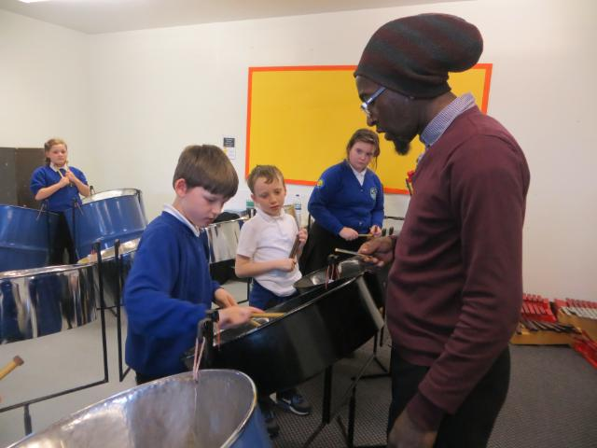
The children’s learning throughout the year culminates in a special, group performance to showcase their skills. This year, the children were so impressive that they were spotted and asked to enter a competition at the Royal Northern College of Music where they received the grade ‘outstanding’ for their achievements. The whole experience taught children to appreciate different styles of traditional drumming and gave the children an enormous sense of achievement.
Every year we celebrate ‘Modern foreign Languages Day’ which is a whole-school, full-day event that acknowledges and celebrates how fortunate we are to have friends at our school of different faiths and cultures. The day begins with a whole school assembly where every child from the school parades through the centre of the hall carrying a flag to celebrate their families’ heritage or their nationality. Children of different cultures are invited to sit on the stage at the front of the hall and wave their flags proudly, for all to see, whilst singing a variety of songs in different languages. Parents and family member are welcome at the event and take a real pride in witnessing the celebration of their nationality. Throughout the day children are given passports and they ‘travel’ around the school visiting different countries (classrooms) where they learn about the traditions of each. Children are given the opportunity to taste a range of food, perform dances and learn new languages.
As a school, we feel that it is important to celebrate every festival throughout the year. This year we hired a fantastic bollywood dancer to teach the children a celebratory dance. The children thoroughly enjoyed this experience and some of the Year 4s shared their knowledge and skills in a whole-school Diwali assembly.

Area 6
With Peace Mala the school actively promotes environmental sustainability, healthy eating, and respect for all animals and wildlife.
At Baguley Hall, the children and teachers are encouraged to work on the promotion and understanding of the concept of peace both locally and nationally. Our environmental work particularly helps as most environmental problems transcend national boundaries and therefore require solutions that are mutually reinforced at global, regional, national and community levels.
Healthy eating and environmental sustainability plays a large part in our school life which was recognised when we gained our ‘Healthy School’ status. The children have lessons on Healthy Eating during PSHCE and through various science topics across the school. They learn all about food groups, the benefits of each group and how to produce a healthy plate of food. All lunchtime meals are freshly prepared by our dedicated school cooks who take a real pride in ensuring that the children are offered a selection of healthy options.

The kitchen staff are always very keen to participate in our Health and Fitness week which consists of five days of varied activities and events to promote health and fitness. This year, the kitchen staff talked to the children about the importance of healthy eating whilst the children made their own fruit kebab. Other events that take place throughout the week include the opportunity to design a balanced meal, science experiments to show the process of bread becoming mouldy and lessons to create tally charts and bar graphs to show the results of sporting events that each class participate in. The week culminates in our whole- school sports day which families and friends are encouraged to be part of. Sports day is a fantastic opportunity for children to practise Peace Mala values such as respect, friendship and team work.
We are fortunate enough to have amazing outdoor areas at our school that we fully engage with during our lessons and the children are always reminded to take care of the environment and respectful of the animals and living things around us.
EYFS have created their own nature environment which consists of a planting area with strawberry plants and a raspberry bush, bird and bee boxes and a quiet area that is covered in bark which is used often when reading the children stories or simply, for quiet reflection. Many lessons involving teaching children how to be kind to nature and how to look after our environment have been planned around this area. We have recently started an Edible Playground Project which has been jointly funded with the postcode lottery. The children and staff will be creating a purpose built allotment, greenhouse and wormery in one of our outdoor areas. The children will be involved in sowing, growing, harvesting and eating/selling the produce. The fruit and vegetables that the children have grown will be served to them at lunchtime.
To ensure that due care and respect is shown to our environment and wildlife, we have got a team of dedicated eco-councillors who meet regularly with their leader Mrs Edge to discuss relevant issues and plan future projects. Over the past year the children have been responsible for ensuring that we save energy by encouraging Teachers and children to turn off lights and IWBs when they are not needed. Our eco-councillors also remind Teachers to switch off electricity at the mains to conserve electricity. They have been responsible for planting bulbs around the school and growing potatoes which the children were able to cook and eat. To ensure that our environment is safe and free from any litter, the Eco-council team and Mrs Edge conduct regular litter picking exercises and promote the use of bins to all children across the school.
We also have a gardening club which is lead by passionate and dedicated members of staff. Over the last year, the children have grown strawberries, mint, potatoes, sweet peas and rhubarb. The children were then given the opportunity to use their freshly grown produce to create meals during our weekly cooking club.

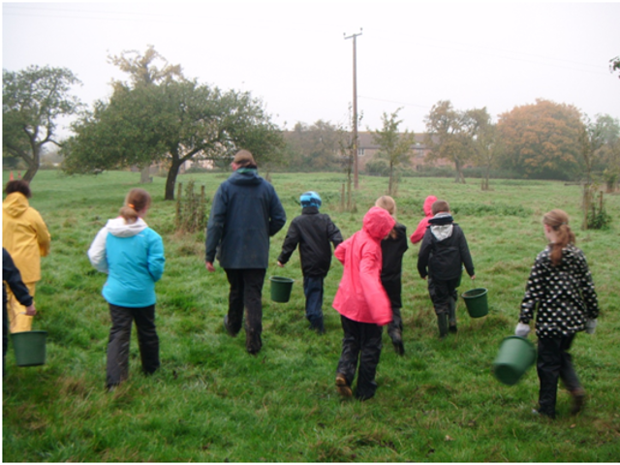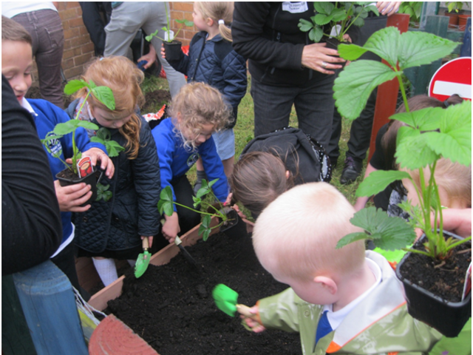

Area 7
With Peace Mala the school encourages Peace Education by forming a School Peace Council and engaging in peace activities.
At the front of our assembly hall we have two, large Peace Mala birds which children love as they are extremely striking. They are used as a visual reminder for the children; showing them the expectations that we have in school. We have two special rooms that are available to all children as a place to go to and have peaceful and calm thoughts. Calm Spaces and The Rainbow Room allow children with specific learning needs to have some quieter, individual time or to participate in small group work with other children of similar abilities or learning needs. These rooms are particularly positive for the children with social and emotional needs as they provide a safe haven for play therapy. The Peace Mala values are referred to and constantly used as a way of teaching the children the importance of valuing and respecting themselves, others and the school environment.
At the beginning of each year, children in every class are nominated by their peers to become a Peace Pal. The children view this role as a real honour and wear their Peace Pal caps around school with great pride. Their key role in school is to spread the message of peace to others through offering help and support to other children if they should need it. Many Peace Pals have resolved minor conflicts during break time and lunch time through simply reiterating the golden message of ‘treating others as you would wish to be treated’.
Throughout the year I meet regularly with the Peace pals and we discuss what we can do to spread the message of peace further. Earlier in the year each Peace Pal planted tulips, in the colours of Peace Mala, around the base of the Peace Pole. The children were delighted to see their hard work come to fruition in the spring when the bulbs began to grow and flower.

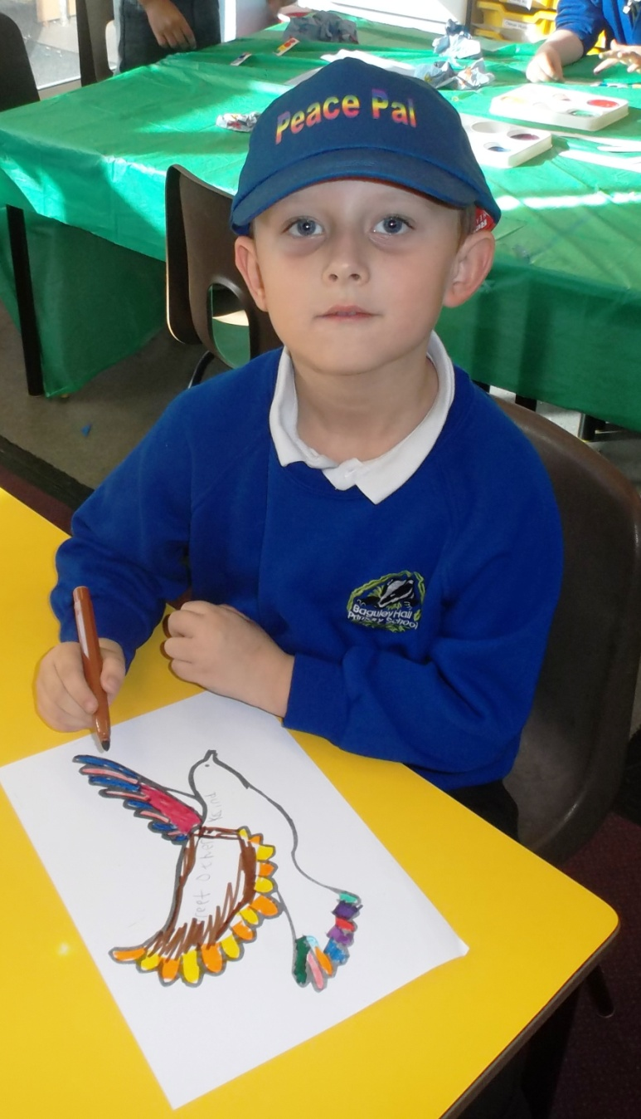
We worked with children across the school to create a Message of Peace; this is similar to a Peace Prayer but instead of focussing on one religion, it encompasses all the beliefs and values that Peace Mala encourages. One of the Year 6 children shared our Message of Peace with the whole-school during our Peace Mala day. To ensure that the values of Peace Mala are always at the forefront of people’s minds, this message is now read by all of the children and staff at the beginning of our weekly celebration assemblies.
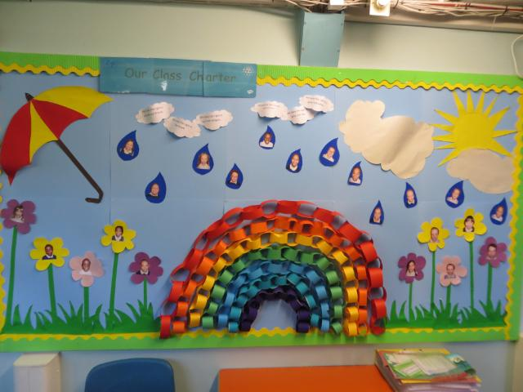

“Since October 2014, our school has altered our RE syllabus to incorporate the teachings of Peace Mala. The impact that this has had to our children has been overwhelming. Through the vital messages that Peace Mala promotes, our children have really connected with the main faiths and religions in a positive and inclusive way. Peace Mala has given our children a much deeper understanding and fostered a real interest and respect in people who have different beliefs to those of our children.
In our multicultural and diverse society, Peace Mala is such an incredibly powerful organisation which plays a vital role to the development of our children.”
Amy Grundy
Year 2 Teacher and Peace Mala co-ordinator
Baguley Hall Primary School,
Wythenshawe, Manchester.
