Creative, Compassionate Education that Empowers and Embraces All
Uniting the World in Peace
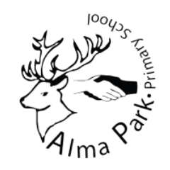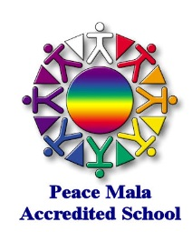
Peace Mala School Accreditation

A Peace Mala School is committed to placing the vision and message of Peace Mala at the heart-centre of its values system. There are seven keys areas for action that we require your school to provide evidence form in the form below. Please write your evidence in the tables below and include photographs.

School Name: | Alma Park Primary School Manchester
Date of Submission: | Summer 2021 | Award Aimed For: Gold

AREA ONE

Becoming a Peace Mala School is part of the whole School Development Plan approved by staff and the Governing Body. This is shared with the whole school community. During every academic year, a chosen year group will study and explore Peace Mala by using the kits and educational materials. This encourages Peace Mala continuity in the school curriculum and ensures that every pupil will have encountered the message and vision of Peace Mala before they leave the school. The school will also share good practice with other schools who are members of the global community of Peace Mala.
Suggested Actions
Peace Mala is in the School Development Plan. Peace Mala presentation to Governors. Peace Mala School Assembly with parents invited. Peace Mala activities explained in Parents Evenings. The school has a prominent designated notice board and web pages or newsletter which details Peace Mala activities. These activities are reported in assemblies and at Governors’ Meetings as well as being regularly communicated to parents and the wider community. View the list of Peace Mala schools on our website - join the list and communicate with each other to share good practice.
- The message of Peace Mala continues to fit beautifully with the ethos at Alma Park Primary School. We have families in our school from over 26 countries and who speak far more languages. We also have children with hearing impairments and physical disabilities. At Alma Park we promote tolerance and respect and the importance of making positive choices in life. Peace Mala was initially introduced to the school in the Autumn of 2010.
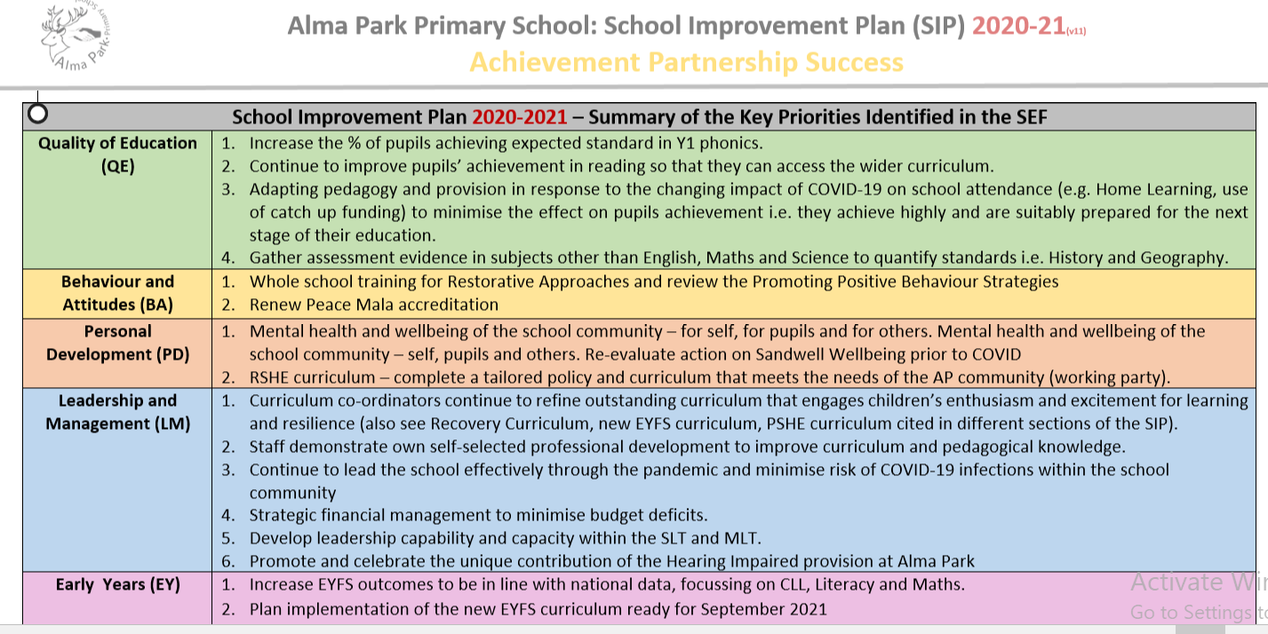
- The message of Peace Mala is embedded at Alma Park and continues to feature in our SDP (achieving Gold is on the 2020/21 targets).

- There is a Peace Mala tab on the school website which shares the message of Peace Mala and links to the Peace Mala website.
- Members of Year Three (Year Four this year) make Peace Mala bracelets and wear them proudly. In addition, they learn about the Peace Mala initiative during lessons and produced beautiful artwork.
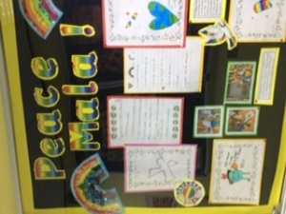
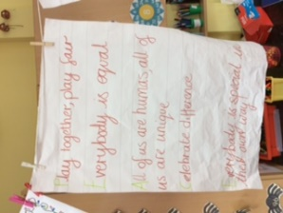
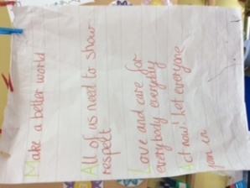
Work produced by year 4 on Peace Mala
- Our year 6 children continued to deepen their awareness of the message of peace and the need for tolerance and acceptance or our friends locally (in school) and globally around the world
- Staff regularly present assemblies to pupils regarding a range of subjects including, natural disasters, values, water aid, diversity and global citizenship.
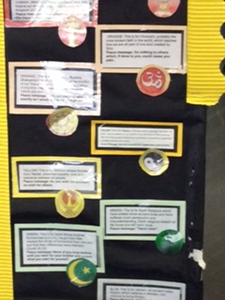
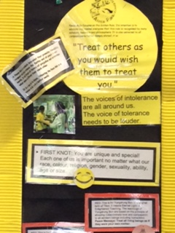
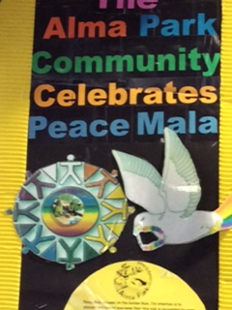
- There is a Peace Mala notice board in the school entrance with quotations and captions that support the golden rule.
Sections of the school Peace Mala notice board
- Our school website has a link to Peace Mala. Peace Mala continues to feature importantly in our SDP for 2020/2021.
- The message of Peace Mala was shared with our wider school community during our Autumn Parents evening in 2019. We intended to do the same in 2020 but were unable to due to the global pandemic. We plan to do so again a soon as it is possible.
- Pupils study the major religions of the world as part of the school’s RE curriculum. This helps to promote the key message of Peace Mala.
- Over time we have achieved many school awards, held events and offered activities that support this e.g. National Healthy Schools Awards, Forest Schools, International Schools Award.
- During lockdown school closure the Headteacher delivered whole school zoom assemblies. Most weeks the topic supported Peace Mala through messages of difference, tolerance and acceptance.
- In 2020, we decided it was time to update our Peace Mala Mural wall in the KS2 playground and we were able to engage with our parents to get them involved.
- We are always eager to share the message of Peace Mala with our colleagues in other schools eg when Acacias were thinking of introducing in their Early Years Setting.
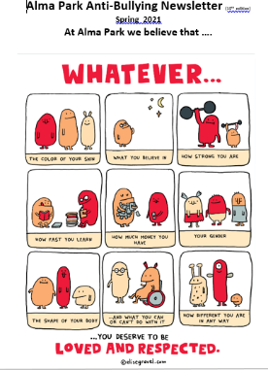
- Families receive an electronic Anti-Bullying newsletter which celebrates work done in school to promote anti-bullying and/or to related information.

A snapshot from our February Anti-Bullying newsletter
- Members of the school community together with Mrs. Hayes, presented the message of Peace Mala to the local Jain community

AREA TWO

By engaging with Peace Mala the school is committed to education for global citizenship through the promotion of understanding, respect, friendship, tolerance and peace between all communities, cultures and enlightened, compassionate faiths. Peace Mala promotes and encourages community cohesion.
Suggested Actions
Lessons and activities on Peace Mala are part of the school curriculum. School assemblies focusing on the Golden Rule.
Evidence
Please provide evidence of Peace Malas made and worn by pupils and staff, both photographic, and/or DVD film and written.
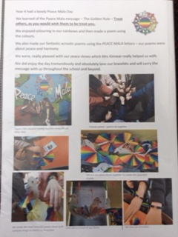
- School Assemblies focus on our school values. Major religious/faith festivals are celebrated in assemblies. During the school closure period, the headteacher led zoom assemblies which often focused on respect, tolerance and difference linked to music. We have an annual Peace Mala focused assembly each year led by Paula Hayes or Denise Samuels.

- The school curriculum offers opportunities for the children to learn about global citizenship, world faiths, our environment and community cohesion
- Pupils have a good understanding of their rights and responsibilities through lessons, school activities, presentations and displays
- The school has written policies and practices which support equality and diversity
- The children display good empathetic skills towards those less fortunate
- All children at Alma Park understand deaf culture and can all use sign language to some degree. The children are taught to sign all of the songs that they learn at school

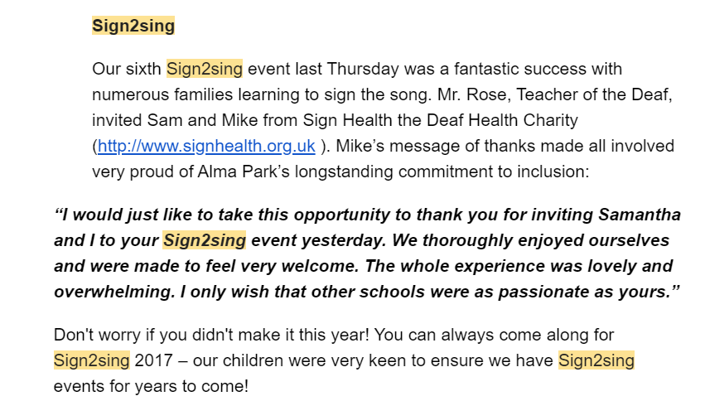
Excerpt from ParentMail message

- We have children at Alma Park School who have physical disabilities. All children continue to work alongside each other in a fully inclusive environment
- We have active links with France. Members of staff have visited Carcassonne and taught in schools there. They have had first-hand experience of life in France. Knowledge and experiences gained have enhanced the learning experiences of children at Alma Park. Our children wrote to the children in France and received letters in reply.
- We have links with Goostrey Primary school in Congleton. When they visited Alma Park we shared the message of Peace Mala. We facilitated a visit to the local Mosque for them as this would be a new experience for the Goostrey School community.
- We have strong links with St. Peter’s Church and Medina Mosque and all year groups will visit each and/or each faith leader will visit school

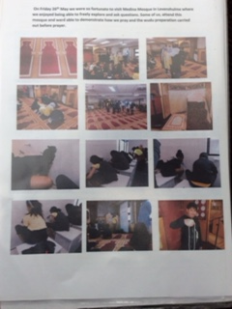
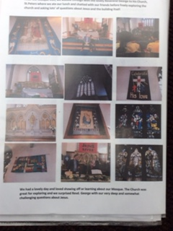
Each year group had a joint visit to the Mosque and local church.

- We invite children and staff from the local Catholic school to attend our school Nativity/Carol concert. Groups of children visit the local OAP home at Christmas to sing carols for the residents

- Deaf culture is promoted and celebrated at Alma Park. Staff and families have access to BSL lessons. This can be from an external provider but is usually in-house training.
- During 2019-20 we supported the Manchester University ‘Speak Up’ Enactus project offering EAL classes for families
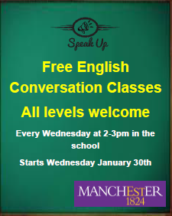 Poster advertising the classes which were attended regularly by families who were new to the UK
- We have links with Manchester High School supporting the setting up of a new R.E. curriculum
- In 2018 we achieved an Anti-Bullying Award
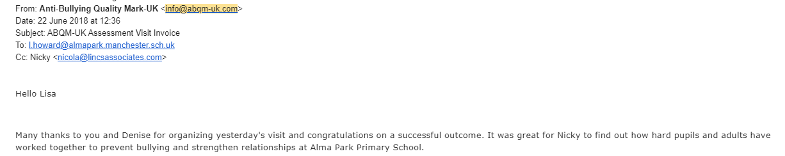
- Our behaviour system is one which promotes reflection, tolerance and making the right choices.

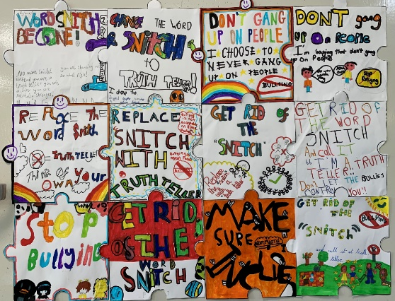

AREA THREE

By using Peace Mala in the classroom, the school supports human rights and helps prevent bullying and all forms of prejudice.
Suggested Actions
Holocaust Memorial Day, City of Sanctuary, Show Racism the Red Card, Anti-bullying policy, Presentation by Hate Crime Police Officer, Playground and Lunchtime 'buddies' Be a Peace Mala friend for the day, engage with CEWC.
The school does not need to engage with all of the above. We would, however, expect them to engage with at least two anti-bullying initiatives over the space of a year.
- Bilingual members of staff are available at the start of each day to meet any needs that parent/carers may have.
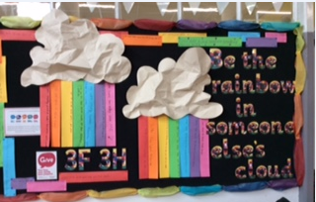
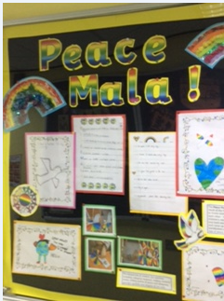
- Initiatives which continue to have a powerful impact upon pupils’ understanding of how to keep safe include Healthy Schools, Road Safety campaign, Bike Right, the School Council, PSHCE, Peace Mala, NSPCA Pantosaurus, and outside agency visitors’ talks.
- All staff at Alma Park work hard to promote positive behaviour choices through our values system, lunchtime behaviour activities, Positive Play and our general Code of Conduct at break times which was originally devised by our SLT in consultation with the School Council and other pupils. The Code is revised regularly and indicates that behaviour is a choice. Sanctions are fair and clear which allows for the consistent approach to managing challenging behaviour and sends a clear message on expected behaviour. Comprehensive behaviour strategies encourage positive behaviour/attitudes by nearly all pupils, who feel safe and respected in school. Most participate positively in learning and feel free from physical and verbal abuse in school. Lunch time supervisors select a Class and pupil of the Week Award. In Spring 2021 all staff took part in training on Restorative Practices. This is part of our continued commitment to find ways to best support our children. We also give weekly Golden Certificates to celebrate/recognise achievements and Peace Mala certificates to those children who have demonstrated acts of kindness.
- Alma Park ABC members are Y6 pupils who apply for the job. They take part in a 10 session peer mentoring training which is delivered by the year six learning mentor. The aim is that ABC member will have a greater understanding of different types of bullying and will feel more confident supporting their peers if such situations occur. Serious playground incidents continue to be extremely rare.
- The ABC lead anti-bullying whole school assemblies each year.
- Incidences of bullying are extremely rare; when reported, they are effectively dealt with and always in partnership with parents/carers. There are procedures for pupils to anonymously report bullying. Pupils report low levels of incidents. The school has close links with local secondary schools to deal with community issues connected with bullying outside the school premises. Good behaviour is an outstanding feature of the school (OFSTED 2013&2017), and frequently receives unsolicited positive comments from members of the public when children are out of school on trips. Classroom observation records frequently comment upon the high standard of good behaviour exhibited by children.
- The PSHCE curriculum and Healthy schools agenda both promote safe and healthy lifestyles and this continues strongly in the new RSHE curriculum which has a strong emphasis on relationships.
- During lockdown school closure the headteacher delivered whole school zoom assemblies. Most weeks the topic supported Peace Mala through messages of difference, tolerance and acceptance.
- There is a Peace Mala notice board in the school entrance with quotations and captions that support the golden rule
- In 2020, we decided it was time to update our Peace Mala Mural wall in the KS2 playground and we were able to engage with our parents to get them involved.

Our fabulous Peace Mala Mural

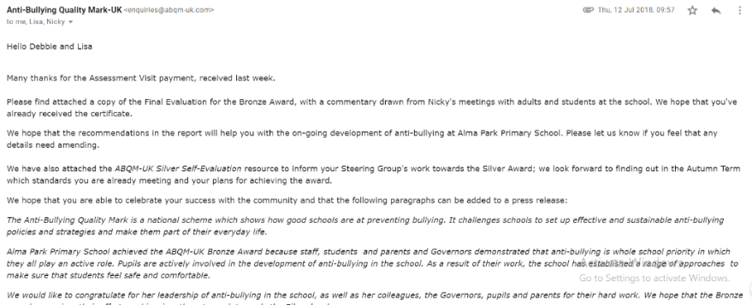
- In 2018, we achieved our first Anti-Bullying Quality Mark from ABQM-UK.

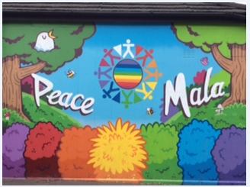
- Holocaust Day is marked with discussions and activities in class

AREA FOUR

Peace Mala encourages the school to raise awareness of issues of global interdependence and encourages active compassion by learners that will lead to positive changes locally and globally.
Suggested Actions
Red Nose Day, Children in Need, Teddies4Tragedy, CEWC, Samaritans Purse Shoe Box Campaign, UNICEF day for change, One World Week, One Life, ActionAid, World Vision, Cafod, SCIAF/TROCAIRE, Christian Aid, Muslim Aid, Healing Hearts Sufi Charity, Afritwin, Nelson Mandela Children's Fund.
The school does not need to engage with all of the above. We would, however, expect them to work with at least two humanitarian NGOs over the space of a year.
Evidence
Please provide newspaper articles, and photographic and written evidence.
- The school currently recycles cardboard, paper, textiles, writing implements, toothbrushes. .
- Alma Park Primary school participates in Red Nose Day and Children in Need. Whole school assemblies led by senior leaders explain these causes and pupils participate in fun activities to raise money for the charities.
- The school promotes fair-trade and activities are built into the KS2 PSHCE / P4C curriculum.
- As a school we support the Poppy Appeal each year
- Harvest festival is celebrated with an assembly each year. In past years collects of food tuff have been donated to the local care homes. This year we decided to give our collection to the local food bank. The there was a vast amount of supplies donated by our families.

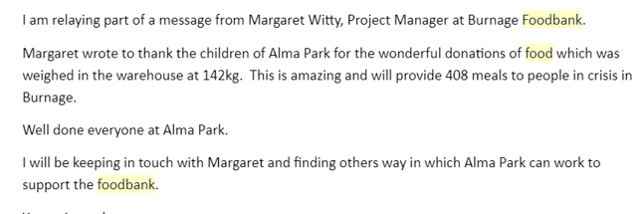

AREA FIVE

Peace Mala encourages the celebration of cultural, racial and religious diversity through art, music, drama and dance.
Suggested Actions
Special assemblies to celebrate cultural and religious festivals. Celebrate One World Week. Links with local faith and cultural communities including churches, mosques, synagogues, gurdwaras and temples. Links with local Inter-Faith group. Cultural school links with schools in Developing Countries through the British Council.
The school does not need to engage with all of the above. We would, however, expect them to work with at least two initiatives over the space of a year.
Evidence
Please provide evidence both photographic and written.
- The school hosted teachers from Pakistan in October 2014. In addition the school has been involved in a British Council Grant bid for teacher’s international visits.
- Pupils at various ages study some of the major world religions and compare faiths and cultures including that of Humanism and consider the Peace Mala message in relation to this. Both infant and junior pupils visit the local places of worship (Mosque, Temple, Church, Gurdwara) and enjoy the many visitors, both faith and non-faith.
- Many religious and cultural festivals are celebrated via our school assembly programme and curriculum planning. Often individuals from the wider school community are invited in to join in with the celebrations relating to their faith/culture. Children and staff from other school are invited to take part in these celebrations eg Christmas, Peace Mala.
- We have a new Peace Mala mural in the school playground.
- The children in year 5 learn about certain aspects of African percussion music through African Djembe drumming lessons
- Annual Sign-2-Sing assemblies are a wonderful example of our school coming together to celebrate Deaf awareness/culture
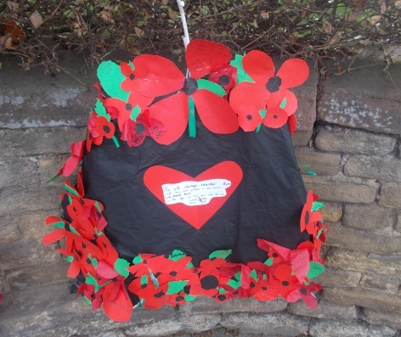
- Remembrance Sunday service Alma Park alongside 3 other schools choir singing songs of peace
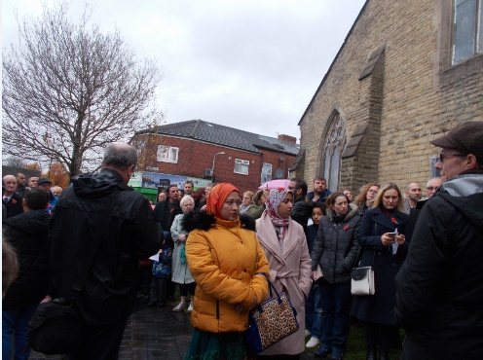
- Children celebrate Charles Darwin day by working on an art project with parental support in the classroom followed by presentation and singing on stage at the Charles Darwin conference held in Manchester city centre
- School community Christmas Carol event – we have warm drinks and mince pies outside after school. The grounds are lit with tealight candles and the school community comes together to sing Christmas carols.
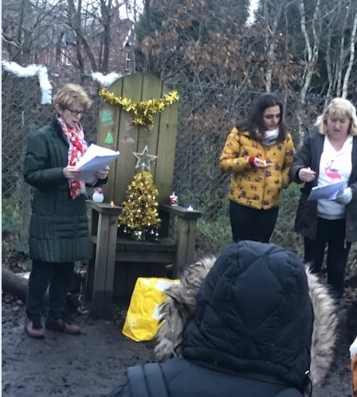

AREA SIX

With Peace Mala the school actively promotes environmental sustainability, healthy eating, and respect for all animals and wildlife.
Suggested Actions
Eco School, Greenpeace Good to be Green initiative, Healthy Eating and Peace Mala Rainbow Foods (as part of the Schools Healthy Eating Initiative), School Eco Council RSPCA, WWF Donkey Sanctuary, RSPB, IFAW.
The school does not need to engage with all of the above. We would, however, expect them to work with at least one green initiative, one school healthy eating initiative and one animal NGO over the space of a year.
Evidence
Please provide both photographic and written evidence, Eco flag, Schools Healthy Eating Certificate.
- Alma Park Primary School has achieved Eco Green Flag status and International Schools Award three times. Nearly all pupils’ attitudes to keeping healthy are very good. Levels of attendance at extra-curricular activities are high.
- The school has been used by the LA catering department as publicity to promote school dinners. Lunchtime organisers give stickers or certificates for pupils with a healthy lunchbox. The LA school meals service, and school staff, works closely to promote healthy lunch boxes Lunchtime choices by children are generally healthy and well-balanced.
- The school’s planned PSHCE programme is enhanced by external visitors some of whom deliver lessons e.g. the local PCSO, NSPCC, School nurse, school dentist, Health Visitor, etc. This ensures that children gain a broad range of experiences designed to promote a healthy, safe lifestyle. Parents often comment that school-based learning has had an impact at home in promoting family health. These experiences will continue when the new RSHE curriculum begins in Summer 2021.
- Almost all children indicate that they would be happy to talk with an adult at school if they had any concerns.
- The school has a dedicated therapy room and has an extensive pastoral team that consists of a trained Counsellor, Play Therapist, Learning Mentors and TAs with specific emotional needs training.
- Many parents state that the school’s beliefs and values have a positive impact upon their children.
- The outdoor learning environment has been enhanced considerably to provide opportunities for physical activity. We have a forest/wild area, playing courts, outdoor classrooms, outdoor story telling areas, trim-trails, buddy benches. Sustainability is promoted successfully through our involvement in the Healthy Schools, waste minimisation and recycling projects and our successful gardening club and has impacted on pupils’ learning.
- When children visit the Peace gardens they are expected to do so peacefully in order to show respect for the environment and the wildlife.
- Opportunities to develop an understanding of global citizenship have been extended through P4C, PSHCE and the sustainable schools programme.
- Multicultural and global citizenship are well planned in a range of subjects and areas of learning and promoted through every aspect of our school life.
- Pupils across the school show respect for all animals and wildlife. Children have made bat and bird boxes and bird feeders for around the school grounds. Foxes, hedgehogs and squirrels are frequent visitors of our school grounds
- The whole school has access to termly Forest Schools lessons. This involves fire making skills, cooking, eating together, tree planting, jewellery making, weaving/basket making etc. All using resources from the environment.

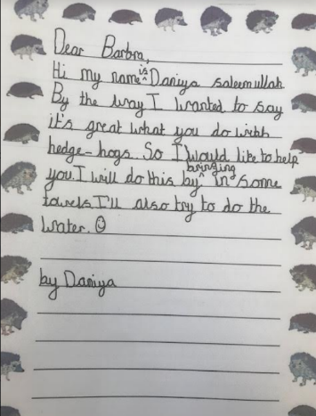
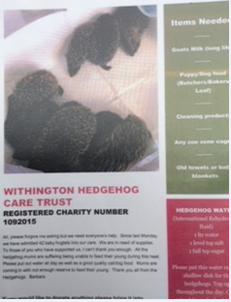
- Hedgehog Appeal

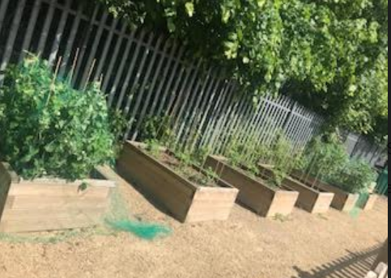
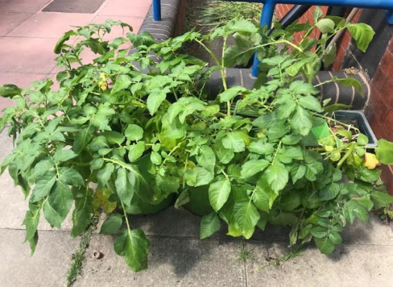

- Whole school planting – each class/year group has a designated planting area. All year groups are planting different fruit and/or vegetables.

- Our HI team support the local Donkey sanctuary annually with fundraising and visits

AREA SEVEN

With Peace Mala the school encourages Peace Education by forming a School Peace Council and engaging in peace activities.
Suggested Actions
School Peace Council. Take part in the Valentine Peace Project. Celebrate UN International Day of Peace. Make a school peace garden with prayer tree or labyrinth. Lessons in mindfulness/meditation/stilling exercises (see guide to the Peace Mala). Community Peace Box. Peace Mala Pilgrimage. Using the Peace Mala to pray for world peace (Peace Mala booklet of Peace Prayers). One Day One Choir.
The school does not need to engage with all of the above. We would, however, expect them to work with at least two peace initiatives
Evidence
Please provide newspaper articles, and photographic and written evidence.
.
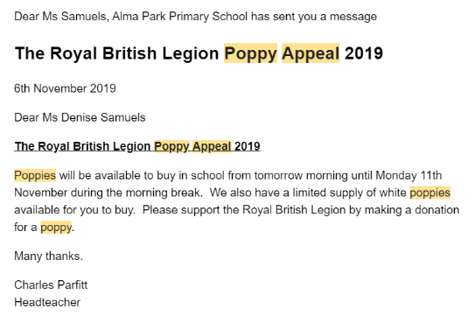
Each year we sell poppies to raise funds and to keep the memories alive of those who lost their lives for peace.

- Our school council are also our Peace Council
- Peace Mala certificates are awarded weekly to children who have displayed acts of kindness
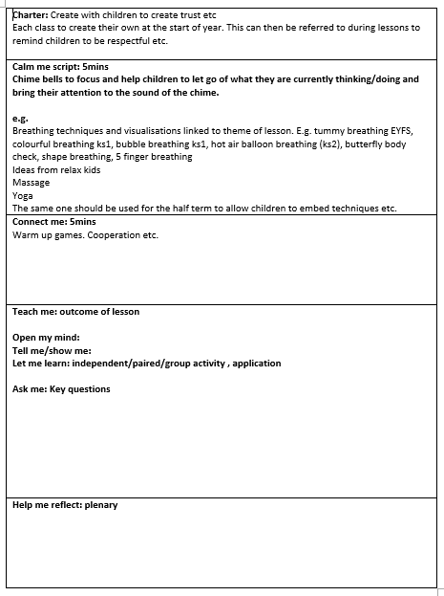
- Lessons in mindfulness/meditation/stilling exercises in Yoga starts of lessons and as part of Religious Education and RSHE lesson

- We planned to revamp our Peace garden last year but this was put on hold as a result of the pandemic. We will continue with such plans in September 2021
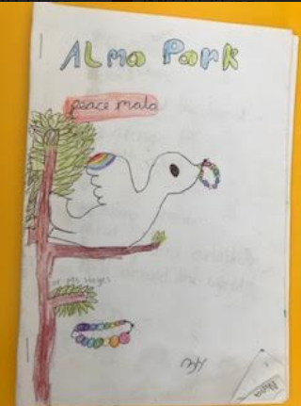
- Use of Peace Mala booklet in Peace Mala day to produce poems and written/drawing/dancing to promote peace
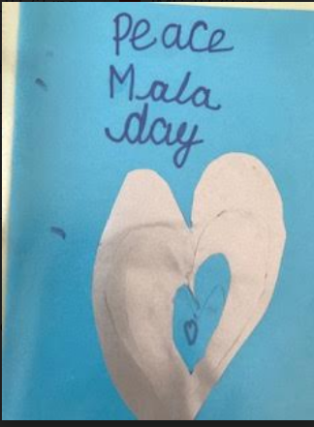
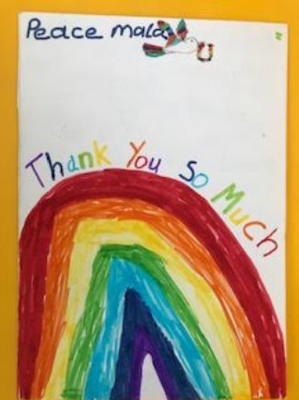

- An Interfaith art project with year 5/6 children led by Manchester University was held for 2 years

- We as a school, promote world peace and tolerance in all that we do.

Thank you for completing your Accreditation Self-Evaluation Form!
As soon as we receive this it will be sent to our Board of Trustees and Educational Advisors for approval.

We look forward to you joining our growing family of Peace Mala Accredited Schools.

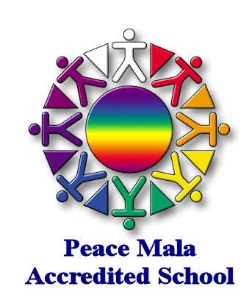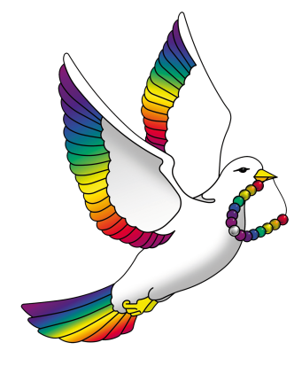

PEACE MALA Registered Office - 122 Clydach Road, Morriston, Swansea SA6 6QB, Wales UK
Tel: +44 (0) 1792 774225 • E-mail: info@peacemala.org.uk

